**Scientific Calculator:**

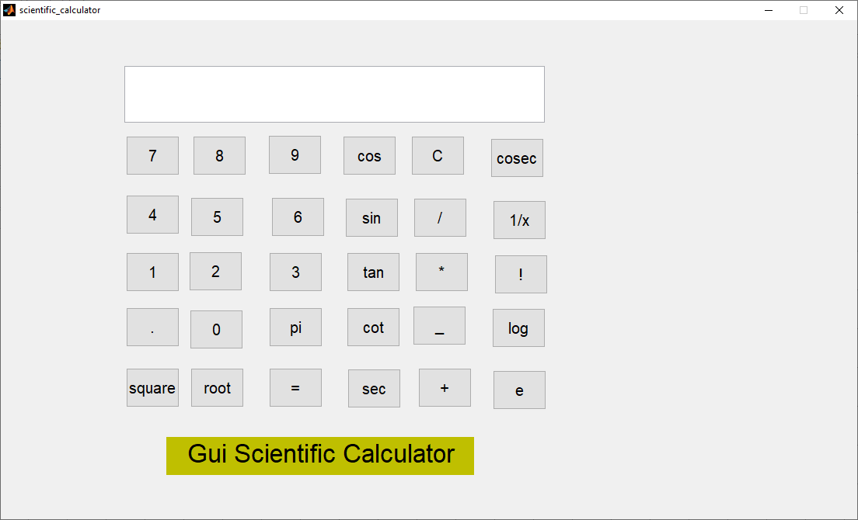

**Variables Tag Name:**

|  |  |
| --- | --- |
| **Variable Name** | **Push Button** |
| **number7** | **7** |
| **number8** | **8** |
| **Number9** | **9** |
| **number6** | **6** |
| **number5** | **5** |
| **number4** | **4** |
| **number1** | **1** |
| **number2** | **2** |
| **number3** | **3** |
| **equals** | **=** |
| **sqaure** | **square** |
| **root** | **root** |
| **comma** | **.** |
| **number0** | **0** |
| **pi** | **pi** |
| **reset** | **C** |
| **division** | **/** |
| **multiply** | **\*** |
| **minus** | **-** |
| **plus** | **+** |
| **cos** | **cos** |
| **sin** | **sin** |
| **tan** | **tan** |
| **cot** | **cot** |
| **sec** | **sec** |
| **cosec** | **cosec** |
| **factorial** | **!** |
| **log** | **log** |
| **exp** | **e** |

**Code:**

function screen_Callback(hObject, eventdata, handles)

% hObject handle to screen (see GCBO)

% eventdata reserved - to be defined in a future version of MATLAB

% handles structure with handles and user data (see GUIDATA)

% Hints: get(hObject,'String') returns contents of screen as text

% str2double(get(hObject,'String')) returns contents of screen as a double

% --- Executes during object creation, after setting all properties.

function screen_CreateFcn(hObject, eventdata, handles)

% hObject handle to screen (see GCBO)

% eventdata reserved - to be defined in a future version of MATLAB

% handles empty - handles not created until after all CreateFcns called

% Hint: edit controls usually have a white background on Windows.

% See ISPC and COMPUTER.

if ispc && isequal(get(hObject,'BackgroundColor'), get(0,'defaultUicontrolBackgroundColor'))

set(hObject,'BackgroundColor','white');

end



% --- Executes on button press in number7.

function number7_Callback(hObject, eventdata, handles)

% hObject handle to number7 (see GCBO)

% eventdata reserved - to be defined in a future version of MATLAB

% handles structure with handles and user data (see GUIDATA)

s=get(handles.screen,'String');

set(handles.screen,'String',strcat(s,'7'));

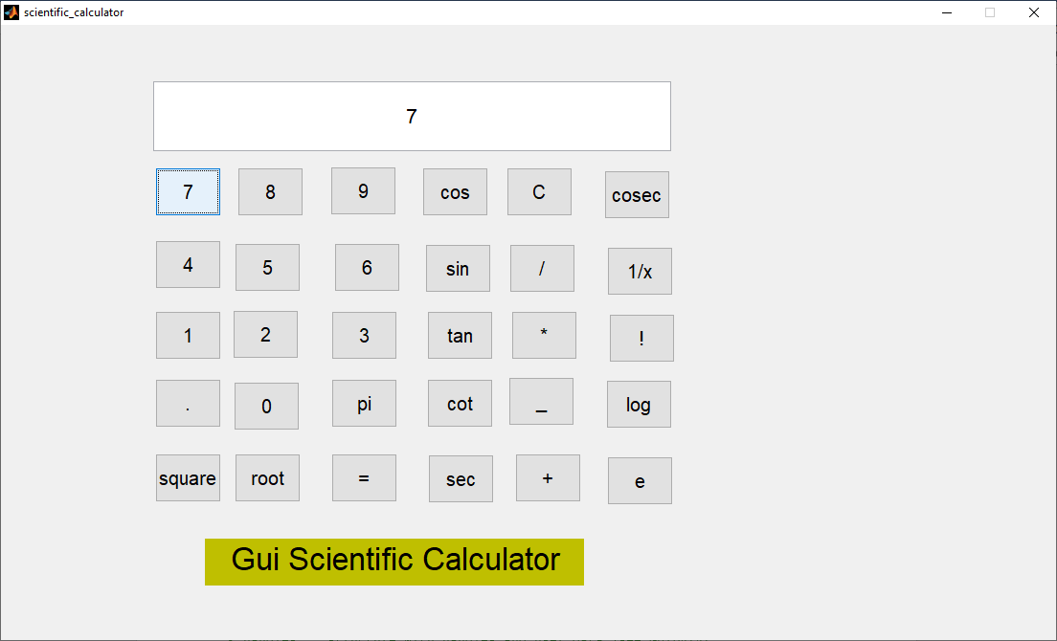

% --- Executes on button press in number8.

function number8_Callback(hObject, eventdata, handles)

% hObject handle to number8 (see GCBO)

% eventdata reserved - to be defined in a future version of MATLAB

% handles structure with handles and user data (see GUIDATA)

s=get(handles.screen,'String');

set(handles.screen,'String',strcat(s,'8'));

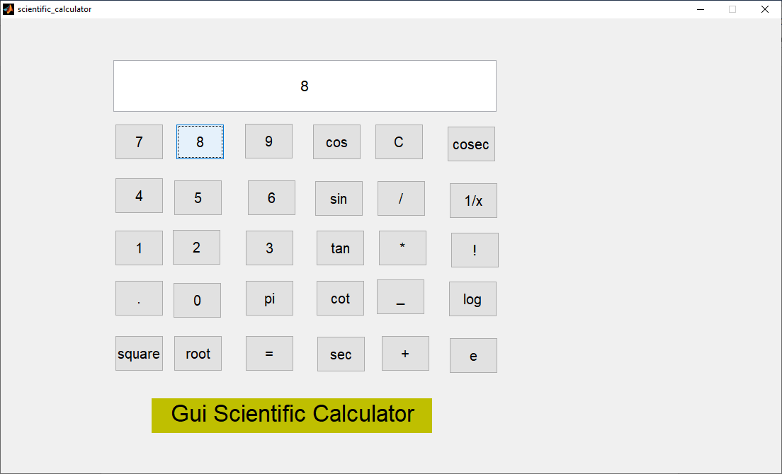

% --- Executes on button press in number9.

function number9_Callback(hObject, eventdata, handles)

% hObject handle to number9 (see GCBO)

% eventdata reserved - to be defined in a future version of MATLAB

% handles structure with handles and user data (see GUIDATA)

s=get(handles.screen,'String');

set(handles.screen,'String',strcat(s,'9'));

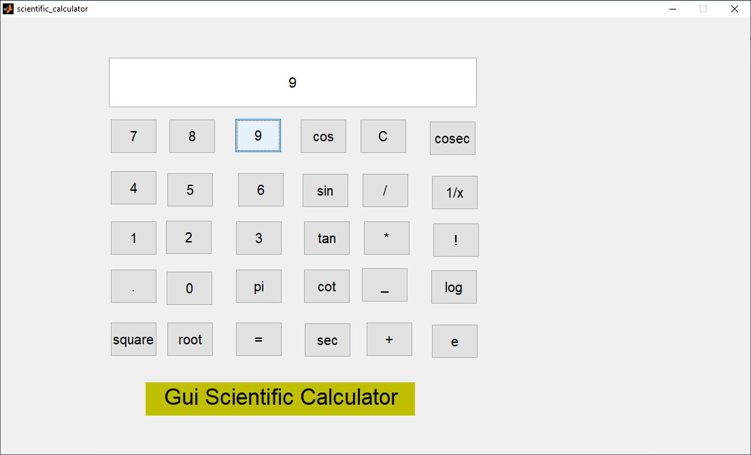

% --- Executes on button press in number4.

function number4_Callback(hObject, eventdata, handles)

% hObject handle to number4 (see GCBO)

% eventdata reserved - to be defined in a future version of MATLAB

% handles structure with handles and user data (see GUIDATA)

s=get(handles.screen,'String');

set(handles.screen,'String',strcat(s,'4'));

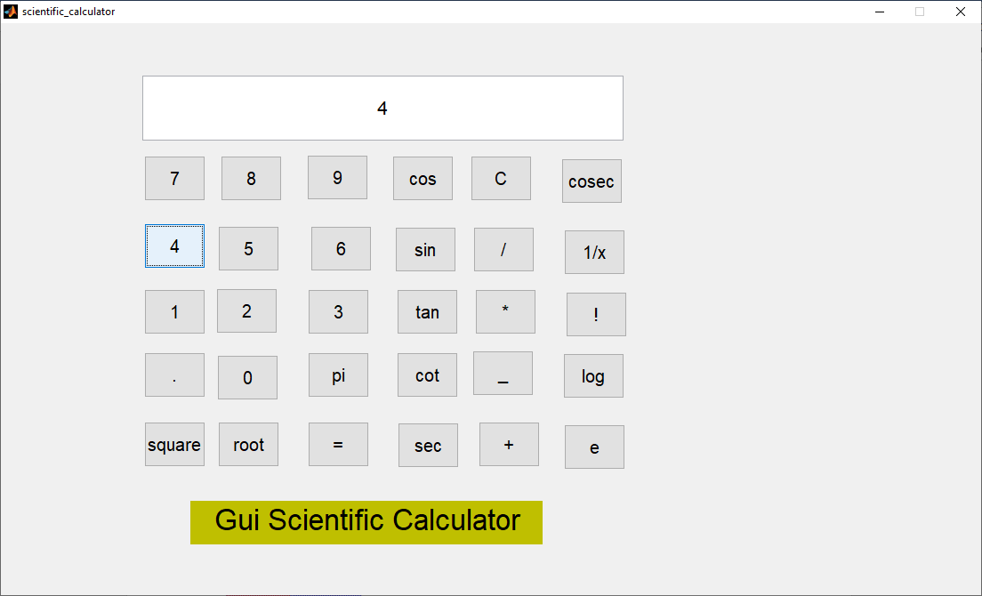

% --- Executes on button press in number5.

function number5_Callback(hObject, eventdata, handles)

% hObject handle to number5 (see GCBO)

% eventdata reserved - to be defined in a future version of MATLAB

% handles structure with handles and user data (see GUIDATA)

s=get(handles.screen,'String');

set(handles.screen,'String',strcat(s,'5'));

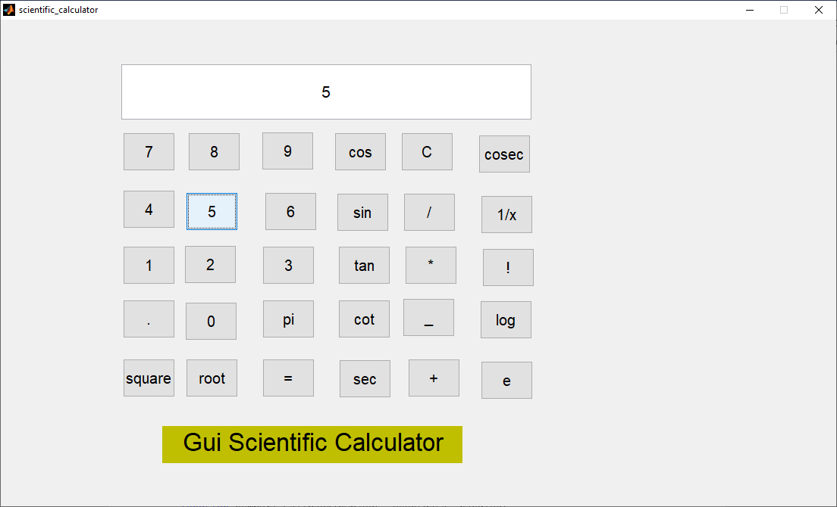

% --- Executes on button press in number6.

function number6_Callback(hObject, eventdata, handles)

% hObject handle to number6 (see GCBO)

% eventdata reserved - to be defined in a future version of MATLAB

% handles structure with handles and user data (see GUIDATA)

s=get(handles.screen,'String');

set(handles.screen,'String',strcat(s,'6'));

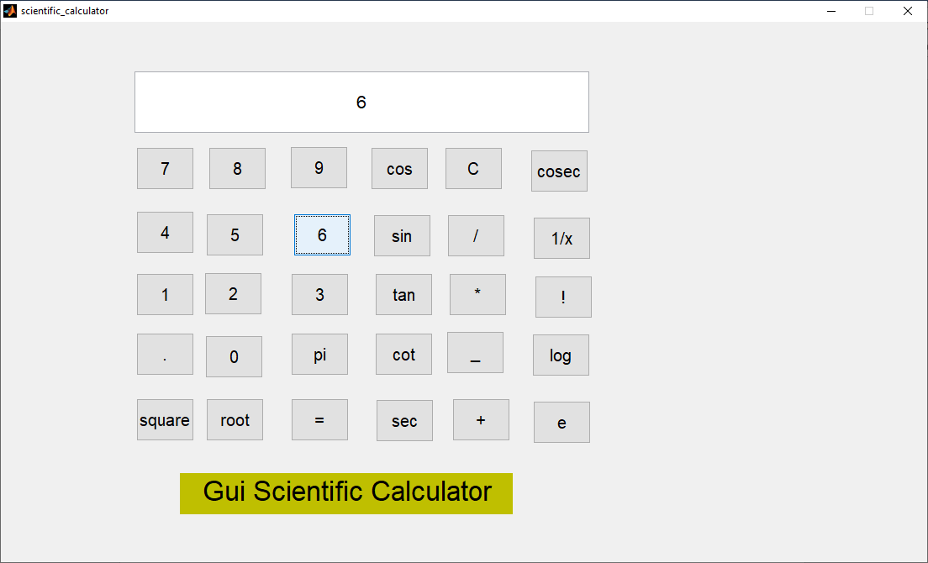

% --- Executes on button press in number1.

function number1_Callback(hObject, eventdata, handles)

% hObject handle to number1 (see GCBO)

% eventdata reserved - to be defined in a future version of MATLAB

% handles structure with handles and user data (see GUIDATA)

s=get(handles.screen,'String');

set(handles.screen,'String',strcat(s,'1'));

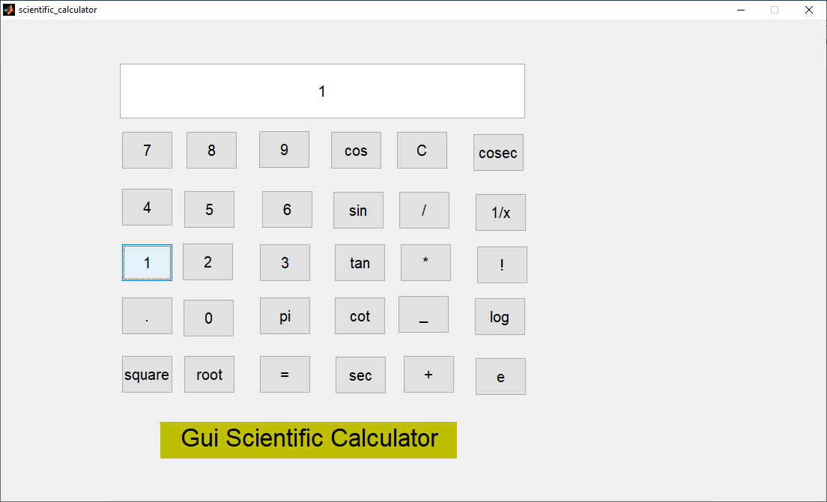

% --- Executes on button press in number2.

function number2_Callback(hObject, eventdata, handles)

% hObject handle to number2 (see GCBO)

% eventdata reserved - to be defined in a future version of MATLAB

% handles structure with handles and user data (see GUIDATA)

s=get(handles.screen,'String');

set(handles.screen,'String',strcat(s,'2'));

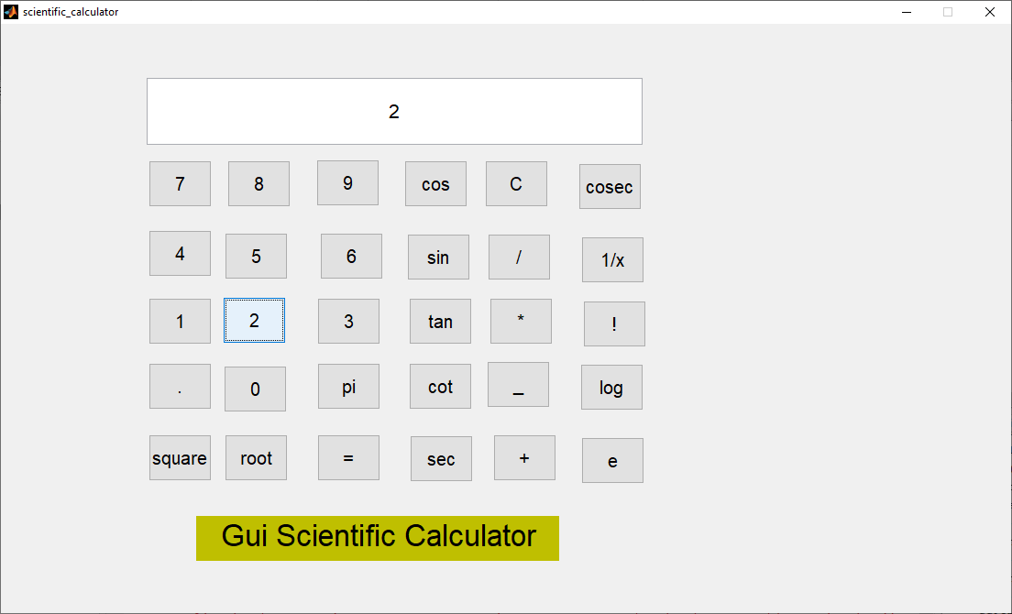

% --- Executes on button press in number3.

function number3_Callback(hObject, eventdata, handles)

% hObject handle to number3 (see GCBO)

% eventdata reserved - to be defined in a future version of MATLAB

% handles structure with handles and user data (see GUIDATA)

s=get(handles.screen,'String');

set(handles.screen,'String',strcat(s,'3'));

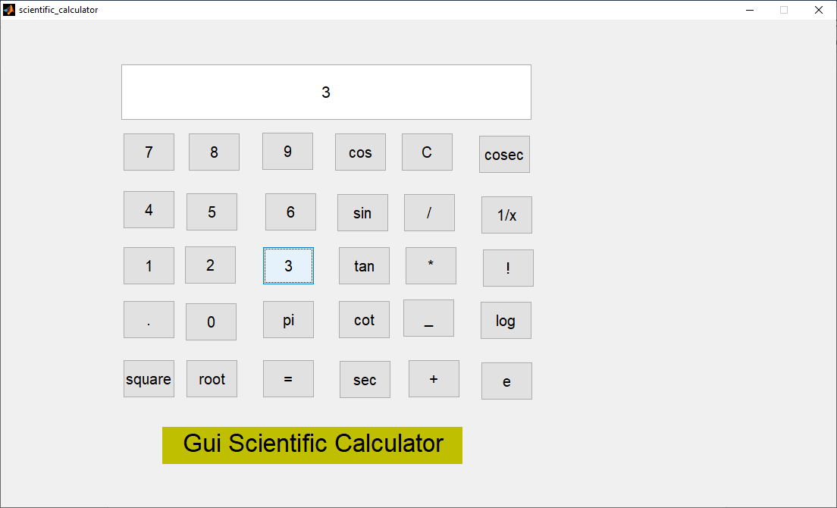

% --- Executes on button press in comma.

function comma_Callback(hObject, eventdata, handles)

% hObject handle to comma (see GCBO)

% eventdata reserved - to be defined in a future version of MATLAB

% handles structure with handles and user data (see GUIDATA)

if not(strcmp(get(handles.screen,'String'),''))

s=get(handles.screen,'String');

set(handles.screen,'String',strcat(s,'.'));

end

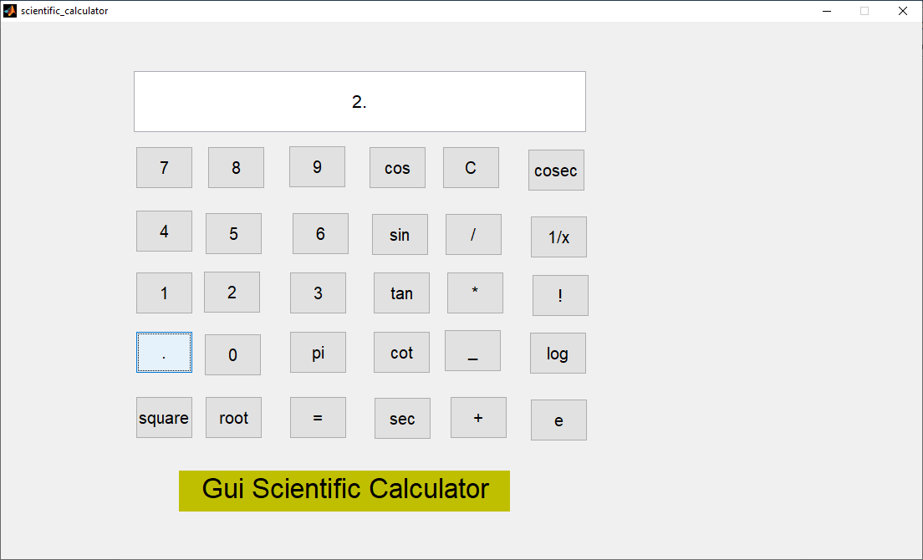

% --- Executes on button press in number0.

function number0_Callback(hObject, eventdata, handles)

% hObject handle to number0 (see GCBO)

% eventdata reserved - to be defined in a future version of MATLAB

% handles structure with handles and user data (see GUIDATA)

s=get(handles.screen,'String');

set(handles.screen,'String',strcat(s,'0'));

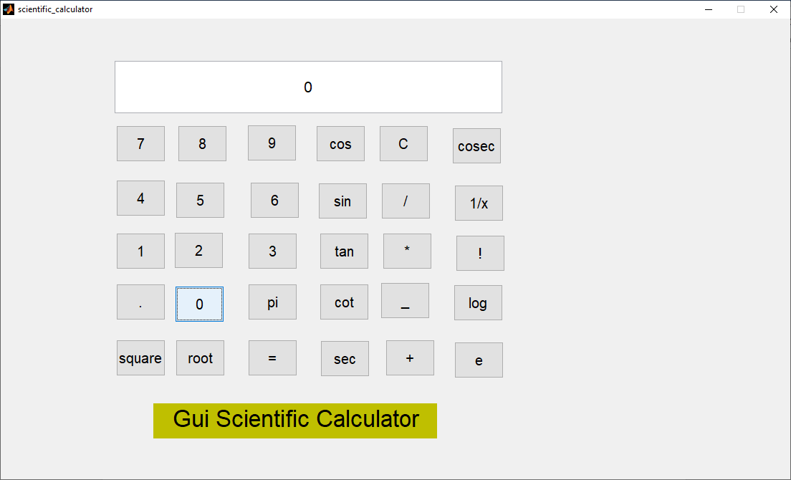

% --- Executes on button press in pi.

function pi_Callback(hObject, eventdata, handles)

% hObject handle to pi (see GCBO)

% eventdata reserved - to be defined in a future version of MATLAB

% handles structure with handles and user data (see GUIDATA)

if strcmp(get(handles.screen,'String'),'')

set(handles.screen,'String','3.14');

else

s=get(handles.screen,'String');

set(handles.screen,'String',strcat(s,'pi'));

end

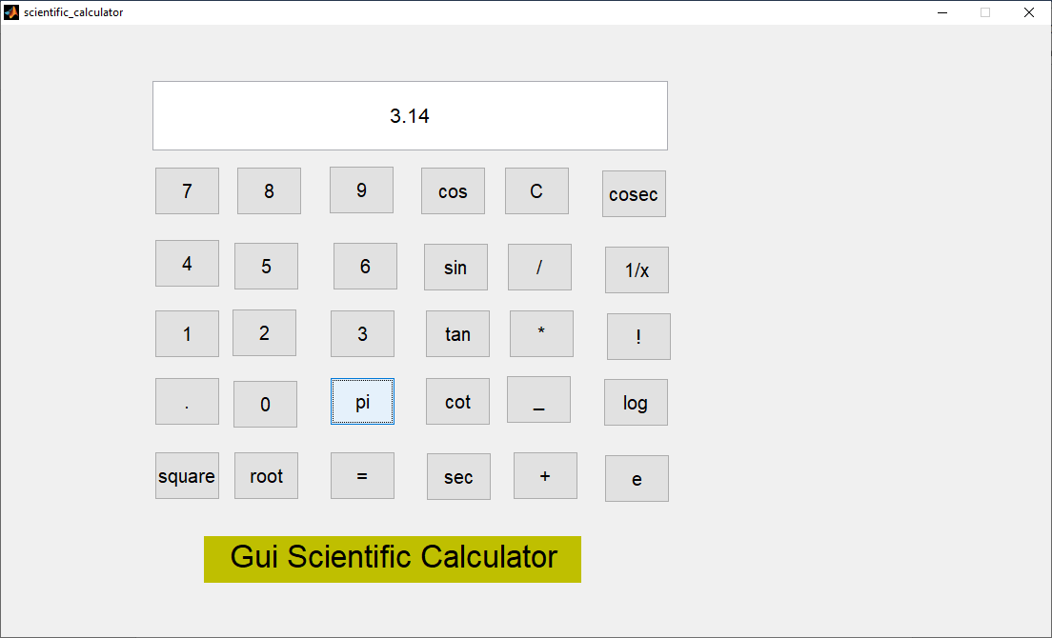

% --- Executes on button press in square.

function square_Callback(hObject, eventdata, handles)

% hObject handle to square (see GCBO)

% eventdata reserved - to be defined in a future version of MATLAB

% handles structure with handles and user data (see GUIDATA)

set(handles.screen,'String',num2str(str2num(get(handles.screen,'String'))^2));

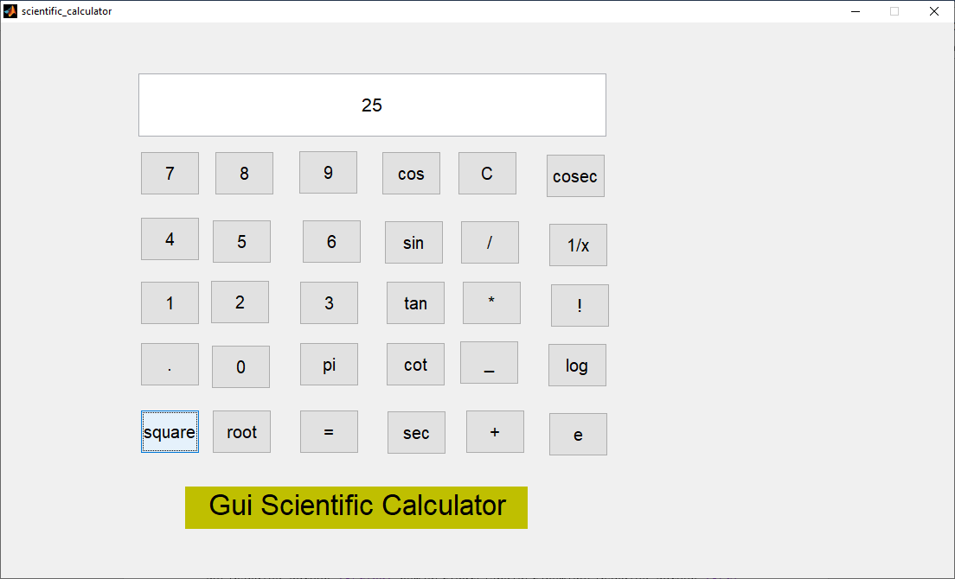

% --- Executes on button press in root.

function root_Callback(hObject, eventdata, handles)

% hObject handle to root (see GCBO)

% eventdata reserved - to be defined in a future version of MATLAB

% handles structure with handles and user data (see GUIDATA)

set(handles.screen,'String',num2str(sqrt(abs(str2num(get(handles.screen,'String'))))));

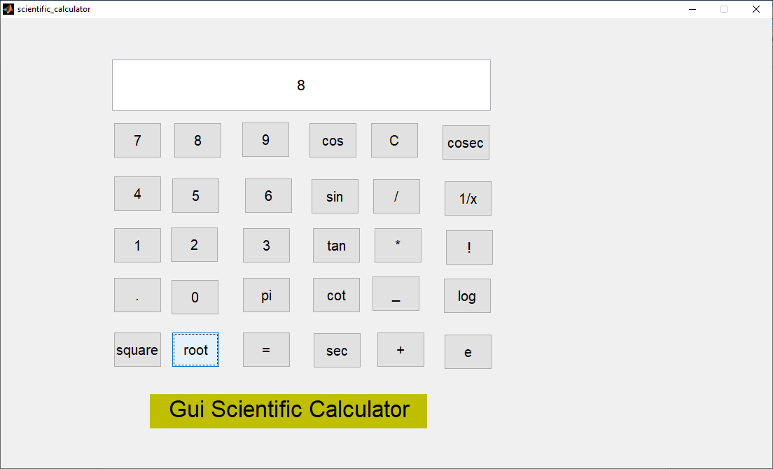

% --- Executes on button press in equals.

function equals_Callback(hObject, eventdata, handles)

% hObject handle to equals (see GCBO)

% eventdata reserved - to be defined in a future version of MATLAB

% handles structure with handles and user data (see GUIDATA)

global a b c d Selector

switch Selector

case 1

a=a/str2num(get(handles.screen,'String'));

set(handles.screen,'String',num2str(a));

case 2

b=b*str2num(get(handles.screen,'String'));

set(handles.screen,'String',num2str(b));

case 3

c=c-str2num(get(handles.screen,'String'));

set(handles.screen,'String',num2str(c));

case 4

d=d+str2num(get(handles.screen,'String'));

set(handles.screen,'String',num2str(d));

end

🡪4/4=1

🡪4*4=16

🡪4-4=0

🡪4+4=8

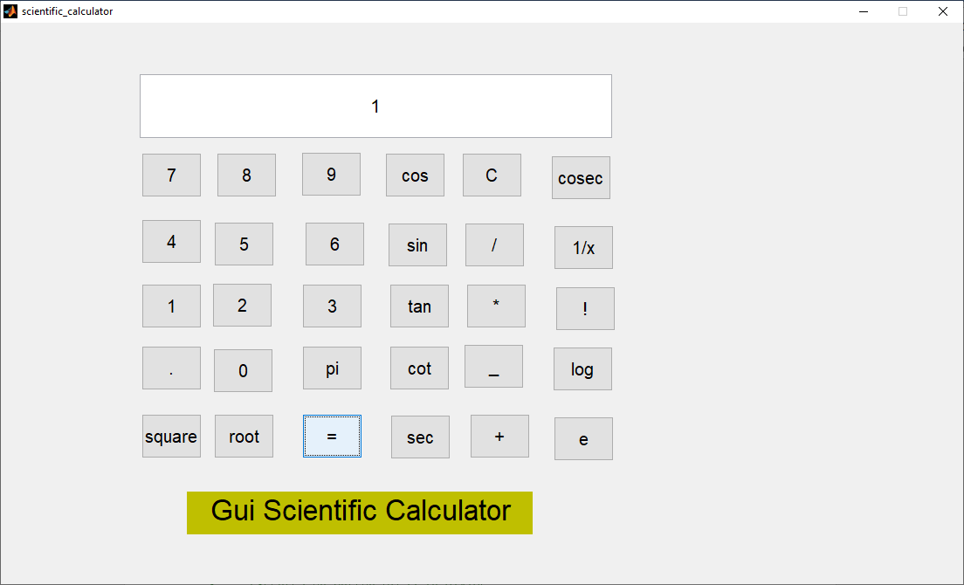 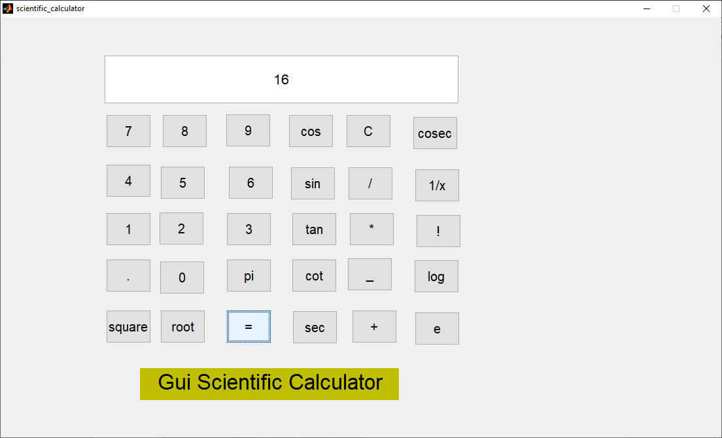

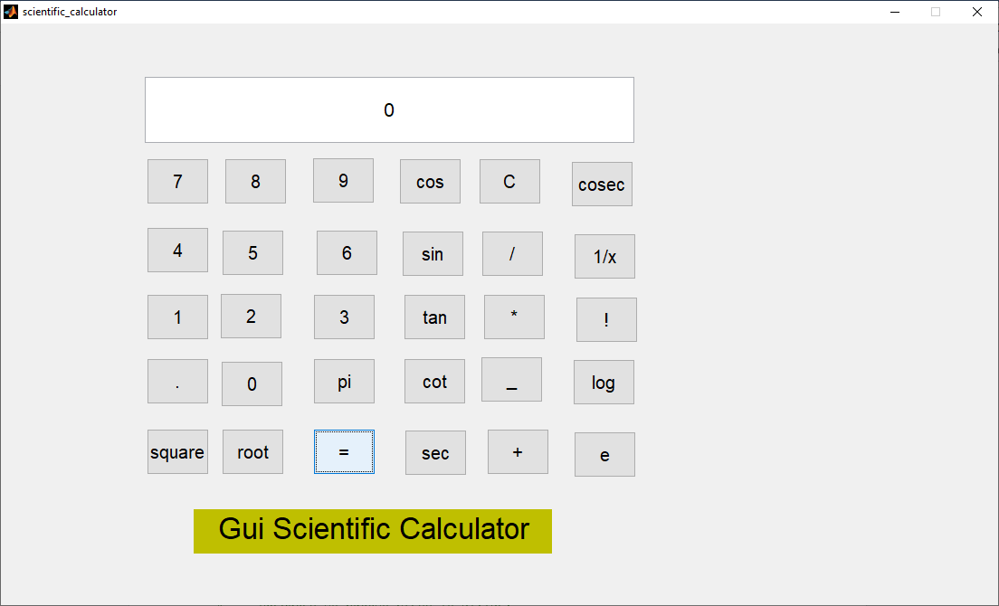 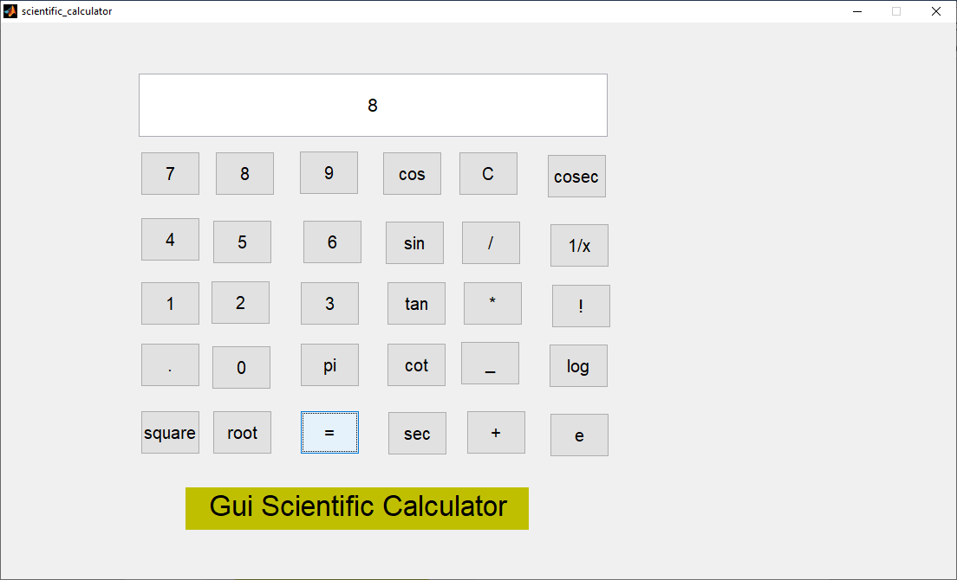

% --- Executes on button press in reset.

function reset_Callback(hObject, eventdata, handles)

% hObject handle to reset (see GCBO)

% eventdata reserved - to be defined in a future version of MATLAB

% handles structure with handles and user data (see GUIDATA)

set(handles.screen,'String','');

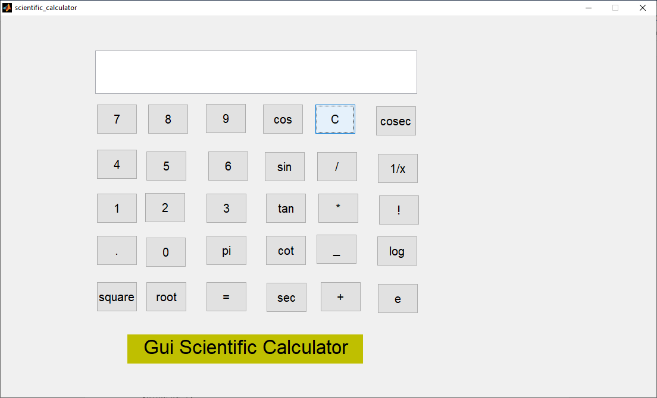

% --- Executes on button press in divide.

function divide_Callback(hObject, eventdata, handles)

% hObject handle to divide (see GCBO)

% eventdata reserved - to be defined in a future version of MATLAB

% handles structure with handles and user data (see GUIDATA)

global a Selector

a=str2num(get(handles.screen,'String'));

Selector=1;

set(handles.screen,'String','');

% --- Executes on button press in multiply.

function multiply_Callback(hObject, eventdata, handles)

% hObject handle to multiply (see GCBO)

% eventdata reserved - to be defined in a future version of MATLAB

% handles structure with handles and user data (see GUIDATA)

global b Selector

b=str2num(get(handles.screen,'String'));

Selector=2;

set(handles.screen,'String','');

% --- Executes on button press in minus.

function minus_Callback(hObject, eventdata, handles)

% hObject handle to minus (see GCBO)

% eventdata reserved - to be defined in a future version of MATLAB

% handles structure with handles and user data (see GUIDATA)

global c Selector

if strcmp(get(handles.screen,'String'),'')

set(handles.screen,'String','-');

else

c=str2num(get(handles.screen,'String'));

Selector=3;

set(handles.screen,'String','');

end

% --- Executes on button press in plus.

function plus_Callback(hObject, eventdata, handles)

% hObject handle to plus (see GCBO)

% eventdata reserved - to be defined in a future version of MATLAB

% handles structure with handles and user data (see GUIDATA)

global d Selector

d=str2num(get(handles.screen,'String'));

Selector=4;

set(handles.screen,'String','');

% --- Executes on button press in cos.

function cos_Callback(hObject, eventdata, handles)

% hObject handle to cos (see GCBO)

% eventdata reserved - to be defined in a future version of MATLAB

% handles structure with handles and user data (see GUIDATA)

set(handles.screen,'String',num2str(cos(abs(str2num(get(handles.screen,'String'))))));

🡪cos(0)=1

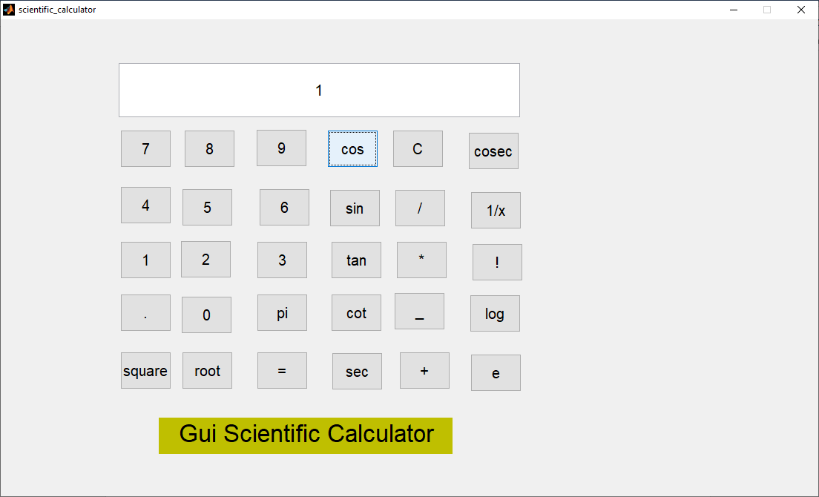

% --- Executes on button press in sin.

function sin_Callback(hObject, eventdata, handles)

% hObject handle to sin (see GCBO)

% eventdata reserved - to be defined in a future version of MATLAB

% handles structure with handles and user data (see GUIDATA)

set(handles.screen,'String',num2str(sin(abs(str2num(get(handles.screen,'String'))))));

🡪sin(90)=0.894

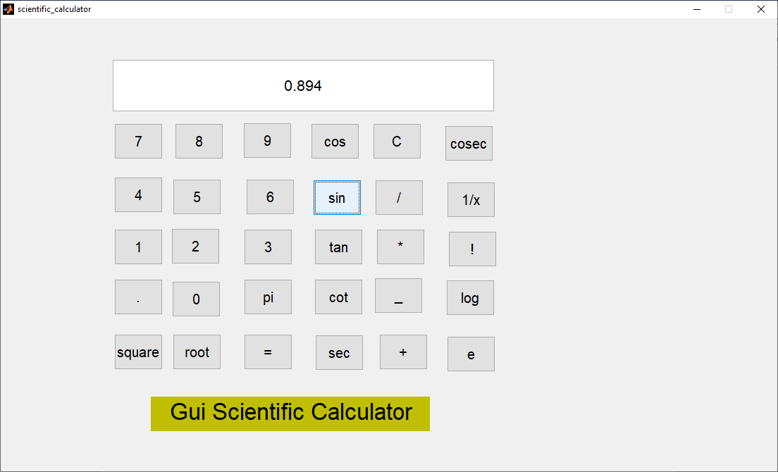

% --- Executes on button press in tan.

function tan_Callback(hObject, eventdata, handles)

% hObject handle to tan (see GCBO)

% eventdata reserved - to be defined in a future version of MATLAB

% handles structure with handles and user data (see GUIDATA)

set(handles.screen,'String',num2str(tan(abs(str2num(get(handles.screen,'String'))))));

🡪tan(60)=0.3204

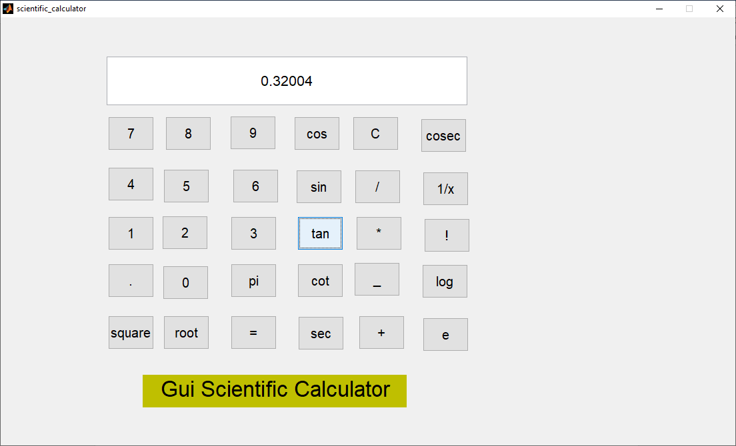

% --- Executes on button press in cot.

function cot_Callback(hObject, eventdata, handles)

% hObject handle to cot (see GCBO)

% eventdata reserved - to be defined in a future version of MATLAB

% handles structure with handles and user data (see GUIDATA)

set(handles.screen,'String',num2str(cot(abs(str2num(get(handles.screen,'String'))))));

🡪cot(90)=-0.5012

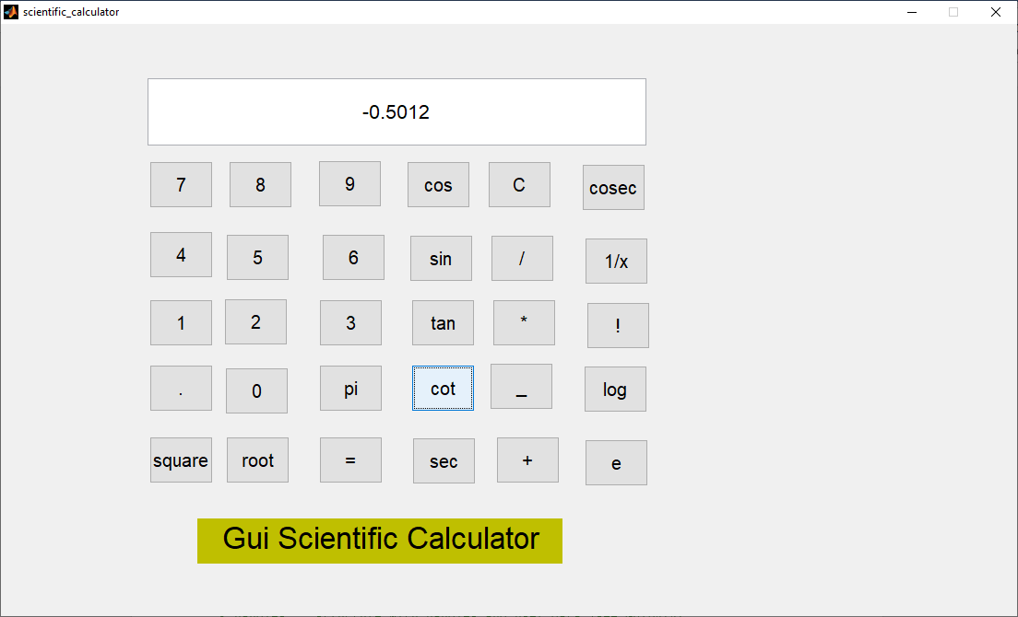

% --- Executes on button press in sec.

function sec_Callback(hObject, eventdata, handles)

% hObject handle to sec (see GCBO)

% eventdata reserved - to be defined in a future version of MATLAB

% handles structure with handles and user data (see GUIDATA)

set(handles.screen,'String',num2str(sec(abs(str2num(get(handles.screen,'String'))))));

🡪sec(90)=-2.2318

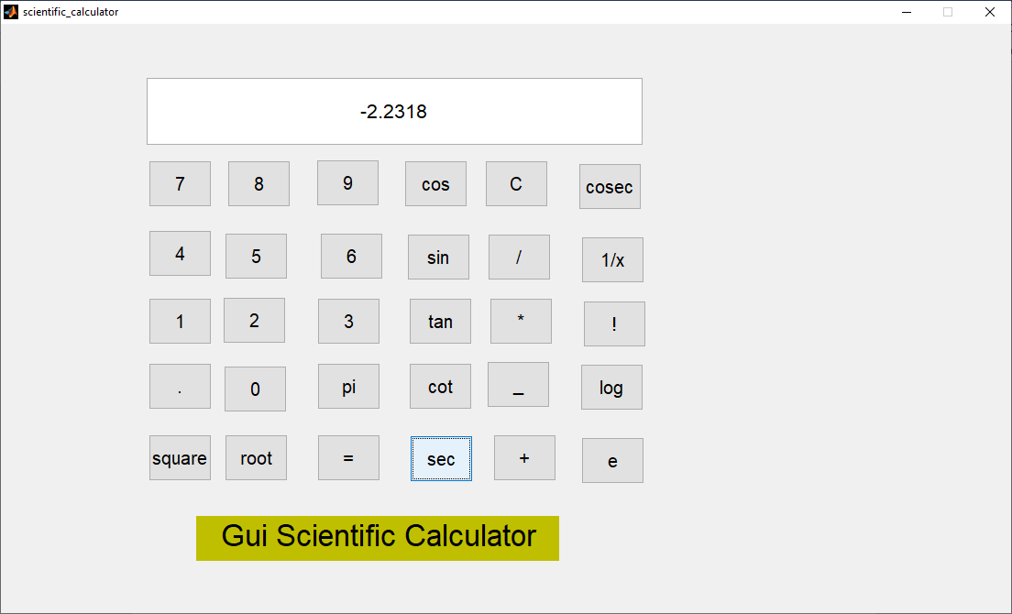

% --- Executes on button press in cosec.

function cosec_Callback(hObject, eventdata, handles)

% hObject handle to cosec (see GCBO)

% eventdata reserved - to be defined in a future version of MATLAB

% handles structure with handles and user data (see GUIDATA)

set(handles.screen,'String',num2str(csc(abs(str2num(get(handles.screen,'String'))))));

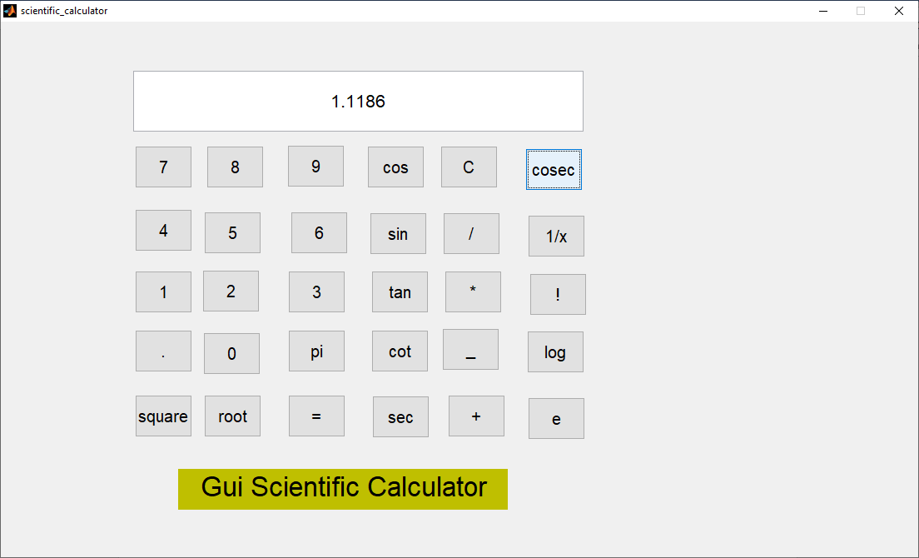

% --- Executes on button press in inverse.

function inverse_Callback(hObject, eventdata, handles)

% hObject handle to inverse (see GCBO)

% eventdata reserved - to be defined in a future version of MATLAB

% handles structure with handles and user data (see GUIDATA)

set(handles.screen,'String',num2str(inv(abs(str2num(get(handles.screen,'String'))))));

🡪inv(10)=0.1

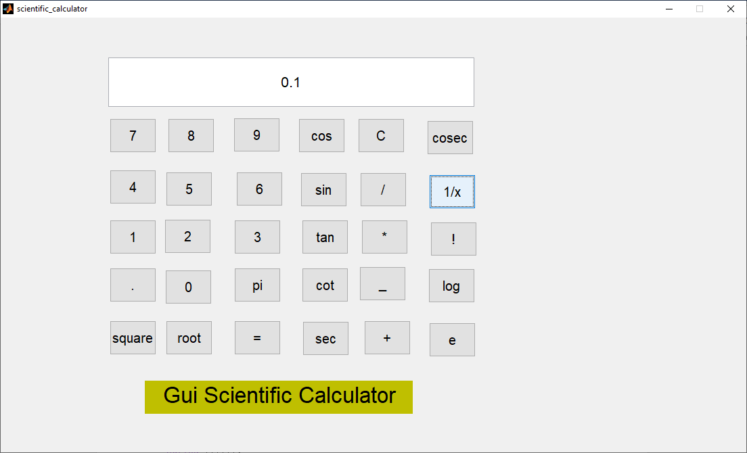

% --- Executes on button press in factorial.

function factorial_Callback(hObject, eventdata, handles)

% hObject handle to factorial (see GCBO)

% eventdata reserved - to be defined in a future version of MATLAB

% handles structure with handles and user data (see GUIDATA)

set(handles.screen,'String',num2str(factorial(abs(str2num(get(handles.screen,'String'))))));

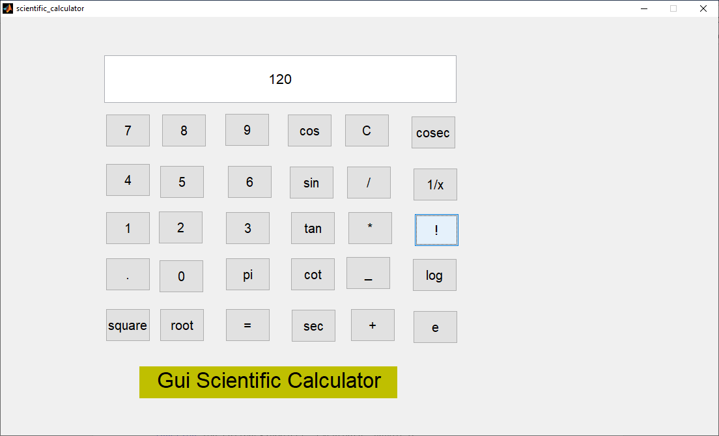

% --- Executes on button press in log.

function log_Callback(hObject, eventdata, handles)

% hObject handle to log (see GCBO)

% eventdata reserved - to be defined in a future version of MATLAB

% handles structure with handles and user data (see GUIDATA)

set(handles.screen,'String',num2str(log(abs(str2num(get(handles.screen,'String'))))));

🡪log(0)=-inf

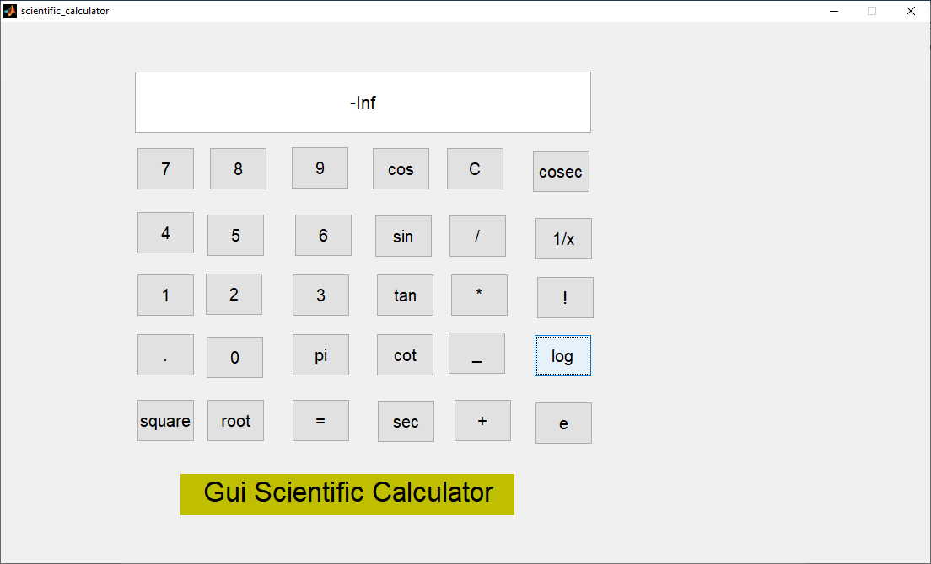

% --- Executes on button press in exp.

function exp_Callback(hObject, eventdata, handles)

% hObject handle to exp (see GCBO)

% eventdata reserved - to be defined in a future version of MATLAB

% handles structure with handles and user data (see GUIDATA)

set(handles.screen,'String',num2str(exp(abs(str2num(get(handles.screen,'String'))))));

